**Database Management System**

**A Sai Vasanthi**

**AP20110010183**

**CSE section C**

**ASSIGNMENT-01**

**Create a data file to store records of the students (fields: rollno, Name, branch,age). Sort the records of the file based on the rollno of the students.**

**Code:**

#include <stdio.h>

struct stu{

int rollno;

char name[100];

char bra[100];

int age;

}s[100];

int main()

{

FILE *file;

int n;

printf("Enter Students Number : ");

scanf("%d", &n);

for(int i = 0; i < n; i++)

{

printf("----------------------\n");

printf("Enter the Roll.no : ");

scanf("%d", &s[i].rollno);

printf("Enter the Name : ");

scanf("%s", s[i].name);

printf("Enter the Branch : ");

scanf("%s", s[i].bra);

printf("Enter the Age : ");

scanf("%d", &s[i].age);

}

for(int i = 0; i < n-1; i++)

{

for(int j = 0; j < n-i-1; j++)

{

if(s[i].rollno > s[i+1].rollno)

{

struct stu swap = s[i];

s[i] = s[i+1];

s[i+1] = swap;

}

}

}

for(int i = 0; i < n; i++)

{

file = fopen("fileop.txt", "a");

fprintf(file, "Name : %s\n", s[i].name);

fprintf(file, "Roll No : %d\n", s[i].rollno);

fprintf(file, "Branch : %s\n", s[i].bra);

fprintf(file, "Age : %d\n", s[i].age);

fclose(file);

}

}

**Input:**

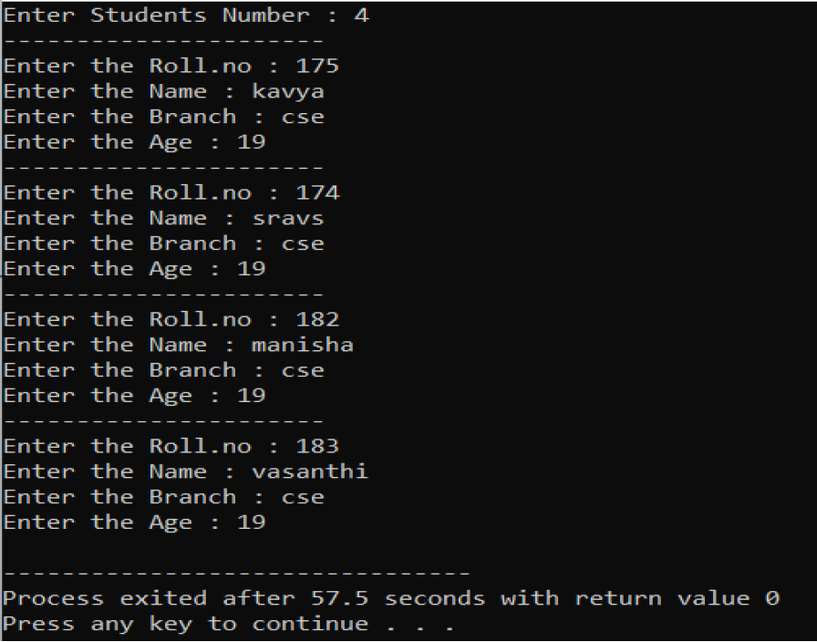

**Output:**



**Perform external sorting procedure (based on the roll number) on two data files which store records of the students and store the result in to the third data file.**

**Code:**

#include<stdio.h>

#include<string.h>

struct student{

char s[25];

int roll;

char b[3];

int age;

};

int main()

{

char ch,k[25],word[50],stu[25],branch[3];

int i,j,r,a,n1,n2,c,tmp,m,p,o,t;

FILE *f1,*f2,*f;

f1=fopen("file1.txt","w+");

f2=fopen("file2.txt","w+");

printf("Enter the number of students for sample1: ");

scanf("%d",&n1);

printf("Enter the number of students for sample2: ");

scanf("%d",&n2);

struct student stude[n1+n2];

int ar[n1+n2];

printf("Enter the data for the file1.txt file:\n");

for(i=0;i<n1;i++){

printf("\nEnter the student name: ");

scanf("%s",stu);

strcpy(stude[i].s,stu);

fprintf(f1,"Name : %s\n",stu);

printf("Enter the Roll Number: ");

scanf("%d",&r);

stude[i].roll=r;

fprintf(f1,"Roll : %d\n",r);

printf("Enter the Branch name: ");

scanf("%s",branch);

strcpy(stude[i].b,branch);

fprintf(f1,"Branch : %s\n",branch);

printf("Enter the age: ");

scanf("%d",&a);

stude[i].age=a;

fprintf(f1,"Age : %d\n\n",a);

}

printf("Enter the data for the file2.txt file:\n");

for(i=0;i<n2;i++){

printf("\nEnter the student name: ");

scanf("%s",stu);

strcpy(stude[i+n1].s,stu);

fprintf(f2,"Name : %s\n",stu);

printf("Enter the Roll Number: ");

scanf("%d",&r);

stude[i+n1].roll=r;

fprintf(f2,"Roll : %d\n",r);

printf("Enter the Branch name: ");

scanf("%s",branch);

strcpy(stude[i+n1].b,branch);

fprintf(f2,"Branch : %s\n",branch);

printf("Enter the age: ");

scanf("%d",&a);

stude[i+n1].age=a;

fprintf(f2,"Age : %d\n\n",a);

}

for(i=0;i<n1+n2;i++)

ar[i]=stude[i].roll;

t=n1+n2;

for(i=0;i<t-1;i++){

for(j=0;j<t-i-1;j++){

if(ar[j]>ar[j+1]){

tmp=ar[j];

ar[j]=ar[j+1];

ar[j+1]=tmp;

}

}

}

for(i=0;i<t;i++){

printf("%d ",ar[i]);

}

fclose(f1);

fclose(f2);

f=fopen("file3.txt","w+");

m=0;

while(m<t){

p=ar[m];

for(i=0;i<t;i++){

if(stude[i].roll==p)

o=i;

}

fprintf(f,"Name : %s\n",stude[o].s);

fprintf(f,"Roll : %d\n",stude[o].roll);

fprintf(f,"Branch : %s\n",stude[o].b);

fprintf(f,"Age : %d\n\n",stude[o].age);

m++;

}

fclose(f);

}

**Input:**

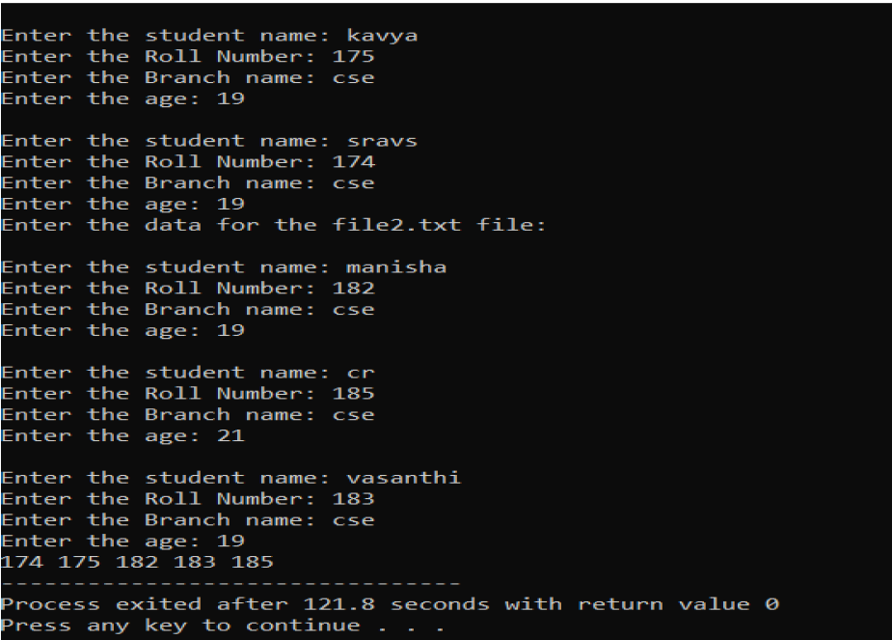

**OUTPUT**:

